Infra & Network Output –

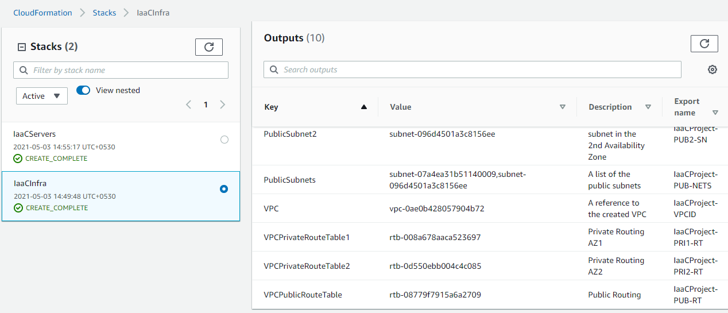

|  |  |  |  |
| --- | --- | --- | --- |
| **Key** | **Value** | **Description** | **Export name** |
| PrivateSubnet1 | subnet-0d930905d36de065b | A reference to the private subnet in the 1st Availability Zone | IaaCProject-PRI1-SN |
| PrivateSubnet2 | subnet-069525ded22b5944e | A reference to the private subnet in the 2nd Availability Zone | IaaCProject-PRI2-SN |
| PrivateSubnets | subnet-0d930905d36de065b,subnet-069525ded22b5944e | A list of the private subnets | IaaCProject-PRIV-NETS |
| PublicSubnet1 | subnet-07a4ea31b51140009 | A reference to the public subnet in the 1st Availability Zone | IaaCProject-PUB1-SN |
| PublicSubnet2 | subnet-096d4501a3c8156ee | A reference to the public subnet in the 2nd Availability Zone | IaaCProject-PUB2-SN |
| PublicSubnets | subnet-07a4ea31b51140009,subnet-096d4501a3c8156ee | A list of the public subnets | IaaCProject-PUB-NETS |
| VPC | vpc-0ae0b428057904b72 | A reference to the created VPC | IaaCProject-VPCID |
| VPCPrivateRouteTable1 | rtb-008a678aaca523697 | Private Routing AZ1 | IaaCProject-PRI1-RT |
| VPCPrivateRouteTable2 | rtb-0d550ebb004c4c085 | Private Routing AZ2 | IaaCProject-PRI2-RT |
| VPCPublicRouteTable | rtb-08779f7915a6a2709 | Public Routing | IaaCProject-PUB-RT |

Server Output –

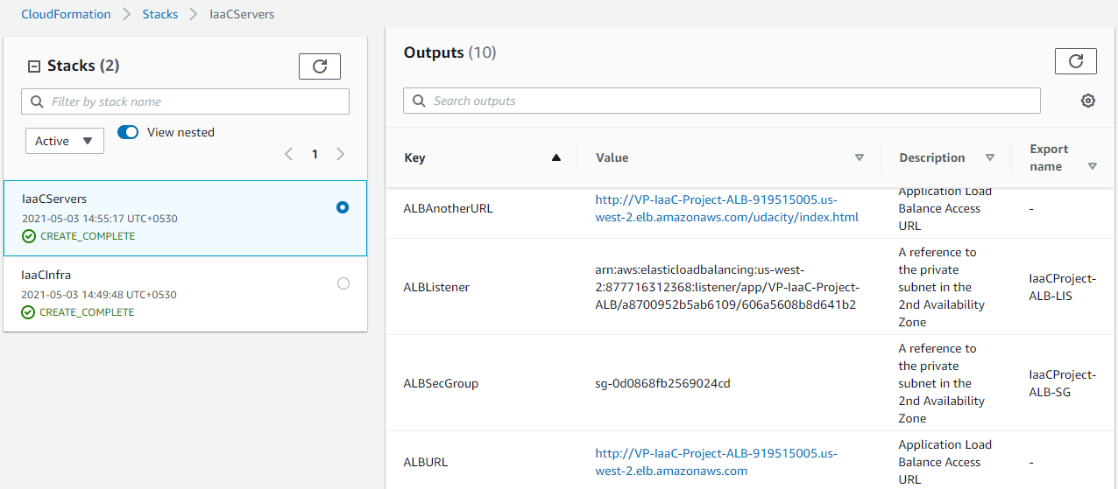

|  |  |  |  |
| --- | --- | --- | --- |
| **Key** | **Value** | **Description** | **Export name** |
| ALBAnotherURL | [http://VP-IaaC-Project-ALB-919515005.us-west-2.elb.amazonaws.com/udacity/index.html](http://vp-iaac-project-alb-919515005.us-west-2.elb.amazonaws.com/udacity/index.html) | Application Load Balance Access URL | - |
| ALBListener | arn:aws:elasticloadbalancing:us-west-2:877716312368:listener/app/VP-IaaC-Project-ALB/a8700952b5ab6109/606a5608b8d641b2 | A reference to the private subnet in the 2nd Availability Zone | IaaCProject-ALB-LIS |
| ALBSecGroup | sg-0d0868fb2569024cd | A reference to the private subnet in the 2nd Availability Zone | IaaCProject-ALB-SG |
| ALBURL | [http://VP-IaaC-Project-ALB-919515005.us-west-2.elb.amazonaws.com](http://vp-iaac-project-alb-919515005.us-west-2.elb.amazonaws.com/) | Application Load Balance Access URL | - |
| Ec2AppServerLaunchConfig | VP-IaaC-Launch-Config | A reference to the private subnet in the 2nd Availability Zone | IaaCProject-EC2-LC |
| Ec2AppServerSecGroup | sg-01404ba5405067726 | A reference to the private subnet in the 2nd Availability Zone | IaaCProject-EC2-SG |
| Ec2AppServerTargetGroup | arn:aws:elasticloadbalancing:us-west-2:877716312368:targetgroup/IaaCS-Ec2Ap-109UE6ZYZ6M3X/5b41d03d88a83f48 | A reference to the private subnet in the 2nd Availability Zone | IaaCProject-EC2-TG |
| Ec2ServerAutoScalingGroup | IaaCServers-Ec2ServerAutoScalingGroup-NTL1HOHQ2OZT | A reference to the private subnet in the 2nd Availability Zone | IaaCProject-EC2-ASG |
| RoleUdacityS3ReadOnlyEC2 | IaaCServers-UdacityS3ReadOnlyEC2-1KF904LWBA0W5 | A reference to the private subnet in the 2nd Availability Zone | IaaCProject-EC2-ROLE |
| myALB | arn:aws:elasticloadbalancing:us-west-2:877716312368:loadbalancer/app/VP-IaaC-Project-ALB/a8700952b5ab6109 | A reference to the private subnet in the 2nd Availability Zone | IaaCProject-ALB |

Website –

<http://vp-iaac-project-alb-919515005.us-west-2.elb.amazonaws.com/>

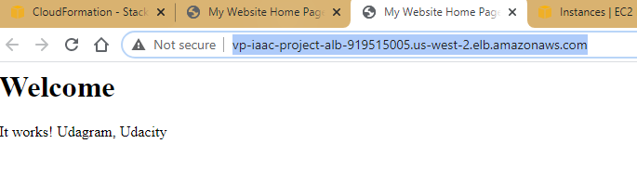

<http://vp-iaac-project-alb-919515005.us-west-2.elb.amazonaws.com/udacity/index.html>

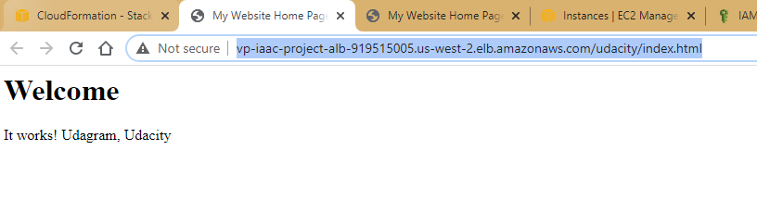

Target Group Health Check –

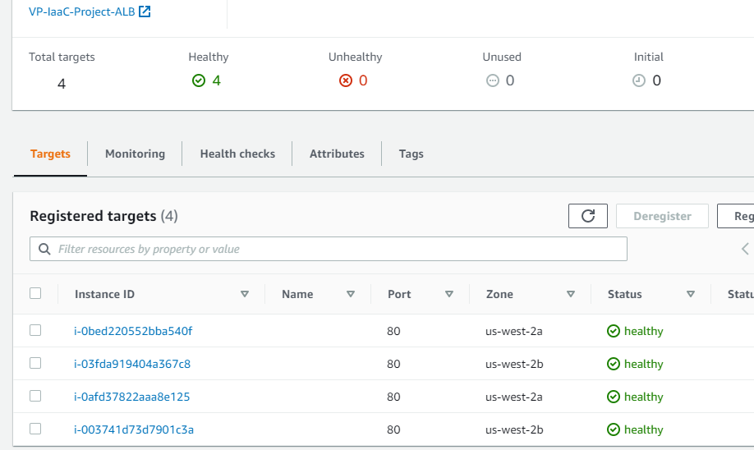

Instances (4: 2 in each AZ) –

